CHAPTER 6: The Earth in space
Worksheet 6.1

The moon
Science Quest 7: pages 219–220
Student: Class:

Moon phases
1. When the face of the moon is fully illuminated it is called a full moon. As the moon continues its orbit of the Earth, less of the lit face of the moon is visible. Eventually the face of the moon becomes dark and then it finally returns to a full moon.
(a) The following diagrams show a jumbled set of moon phases. Use the letters A — H to arrange them in the correct order starting with a full moon.
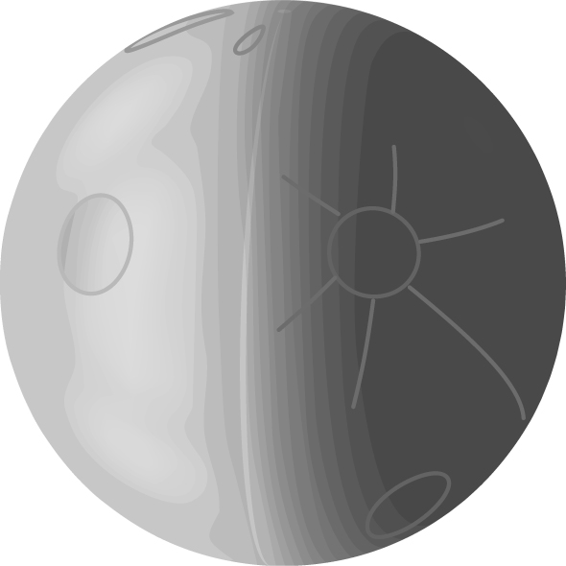  A B C D | 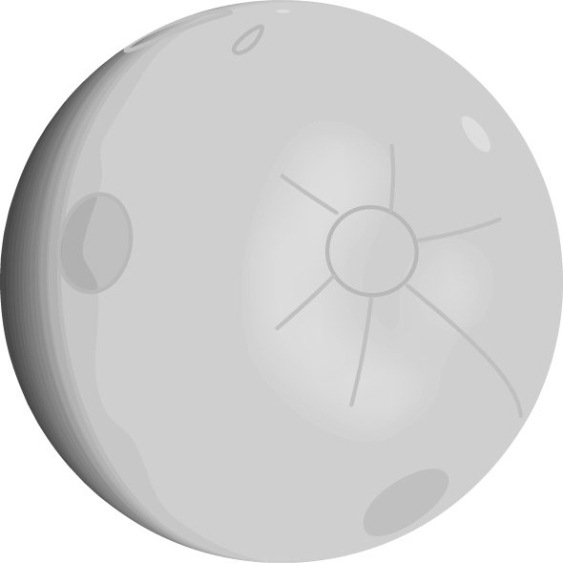 |  | 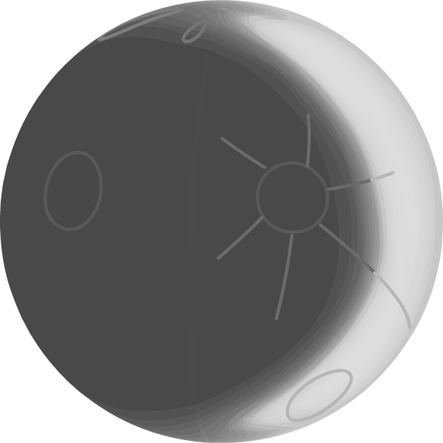
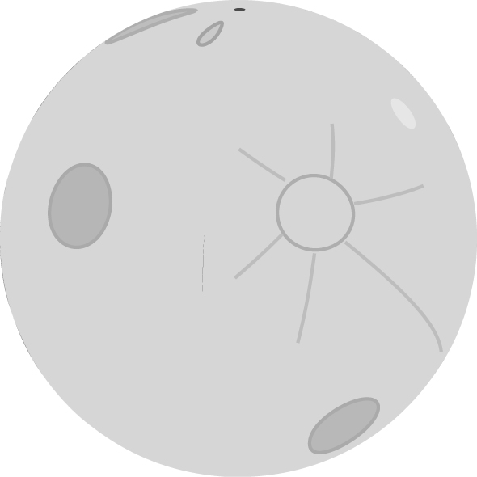  E F G D | 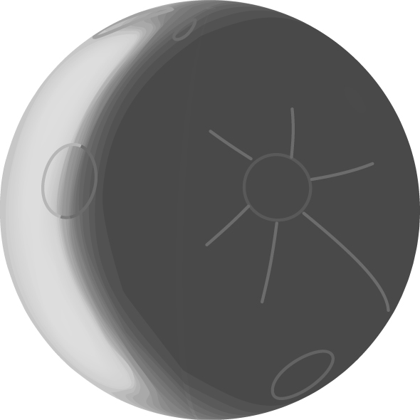 | 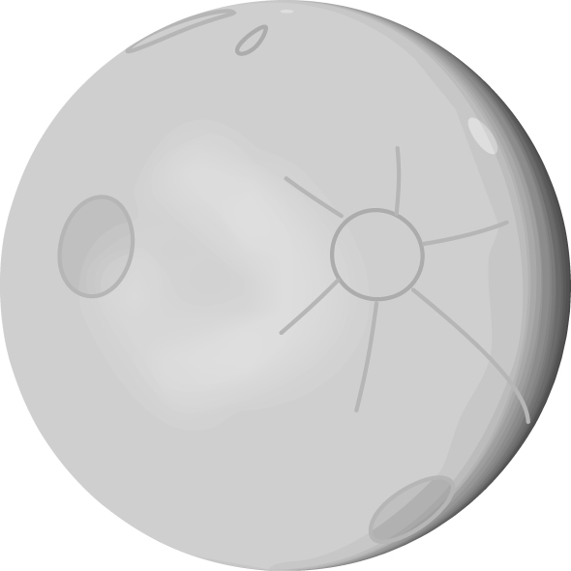 | 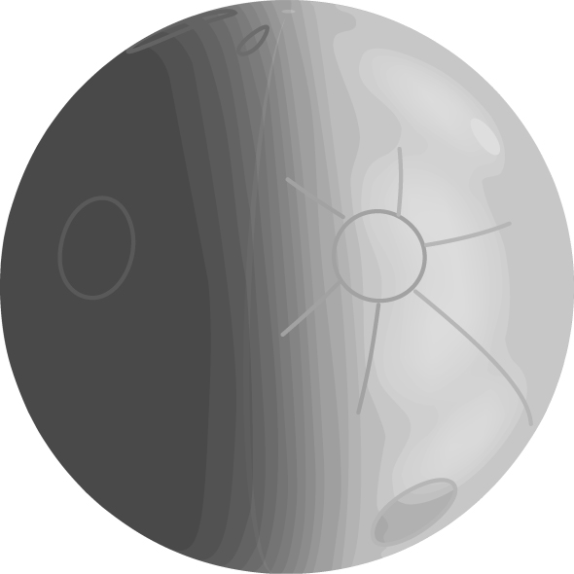
Correct order =

(b) Match the letter sequence above to the number sequence in the diagram below.
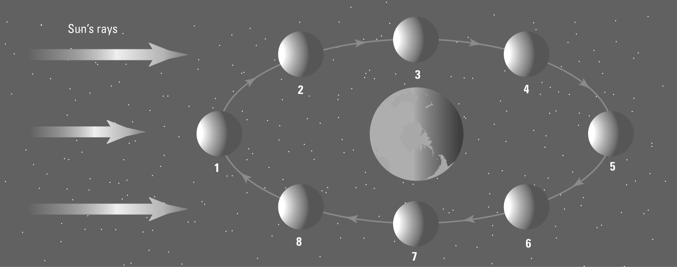

1: ....... 2: ....... 3: ....... 4: ....... 5: ....... 6: ....... 7: ....... 8: .......
Hecate
Diana
Increasing area of the moon in brightness; more of the moon’s surface is illuminated.
F
CHAPTER 6: The Earth in space PAGE 2
Worksheet 6.1

The moon in Greek mythology
2. Read the following information and answer the questions that follow.
The ancient Greeks believed the moon to be a female god. They gave her different names depending on the face she showed to the people of Earth. When her face became dark they called her Hecate. When her face was full they called her Selene. When her face was a waxing crescent they called her Diana. The ancient Greeks believed that the changing face of the moon was related to the cycles of birth, aging and death.
(a) Which name for the female god would be associated with death?

(b) Which name for the female god would be associated with growth?

(c) Look up the meaning of the word waxing.

(d) Which image of the moon in question 1 corresponds with a waxing crescent?

